Tony Maccio March 7, 2014
Director of Housekeeping
Langham Chicago
330 North Wabash Avenue
Chicago, IL 60611
E mail: tony.maccio@langhamhotels.com

Dear Mr. Maccio:

Thank you very much for the opportunity to earn your business. We are pleased to present you this proposal for the deep restoration cleaning of your upholstery. If you have any questions regarding my proposal, please do not hesitate to call me.

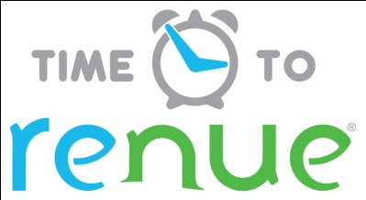

Why choose Renue Systems for your deep cleaning needs?

- We are the leading provider of comprehensive deep cleaning services exclusively to the hospitality industry – we have proudly serviced thousands of hotels over our 30 year history
- We are the only company that has been a North America approved vendor of Avendra since its formation
- Expertly trained, certified and uniformed employees that specialize in working in the hotel environment – no micromanaging of our team by your team is needed
- Proprietary equipment and chemicals, well-tested methodologies and significant ongoing R&D to provide top results
- Extremely responsive scheduling and highly flexible payment plans to meet your changing needs – we work when it is convenient to you and on a 24/7 basis
- Easy to understand and transparent pricing – and all our work is 100% guaranteed to your satisfaction

At your property we will perform the following methodology, a well-tested technique we have developed over the years in conjunction with the leading deep floorcare cleaning association and the largest floorcare manufacturers:

Our deep, dry clean process-

- INSPECTION: All carpeting is inspected to determine fiber consistency. Wool carpet and synthetic carpet must be treated very differently
- SAFETY: Wet floor signs, carpet runners and caution cones are placed in the immediate work area to ensure the safety of your guests and employees during our cleaning
- VACUUM: Material to remove all dry soil.
- DRY CLEAN: Upholstery using Renue System’s exclusive portable dry cleaning process that includes a specialized machine that heats odorless mineral spirits used during the dry cleaning process. The odorless mineral spirits is heated to a very hot temperature within the machine. The heated solution and process insures safe cleaning for all delicate dry clean only material that may stain or deteriorate with the use of conventional water based cleaning agents and methods.

Project details and costs for proposed cleaning

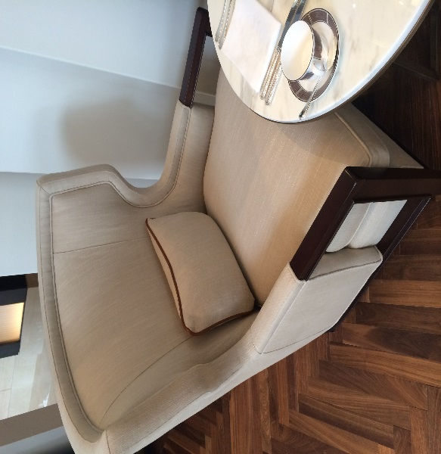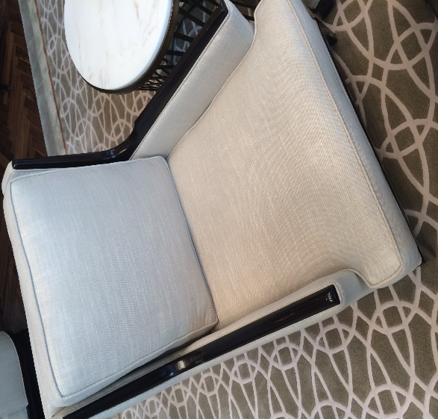
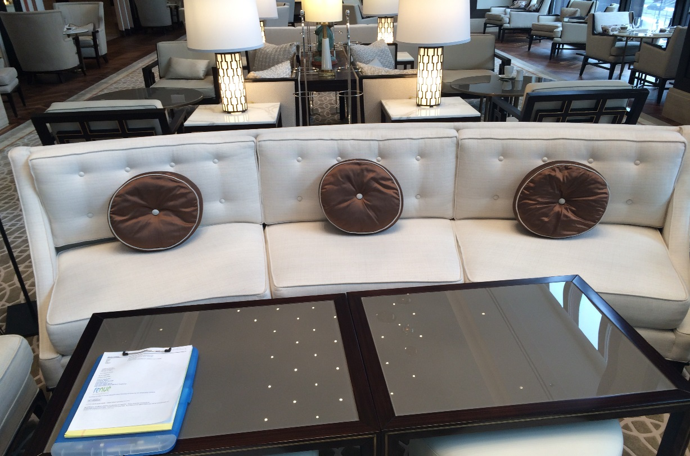

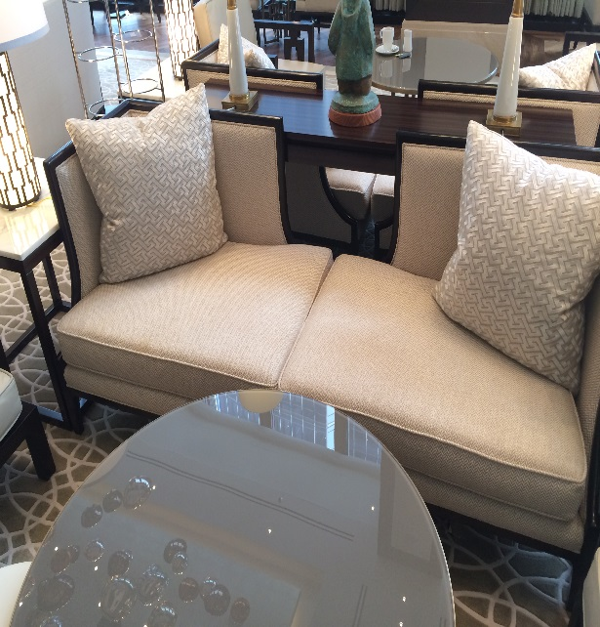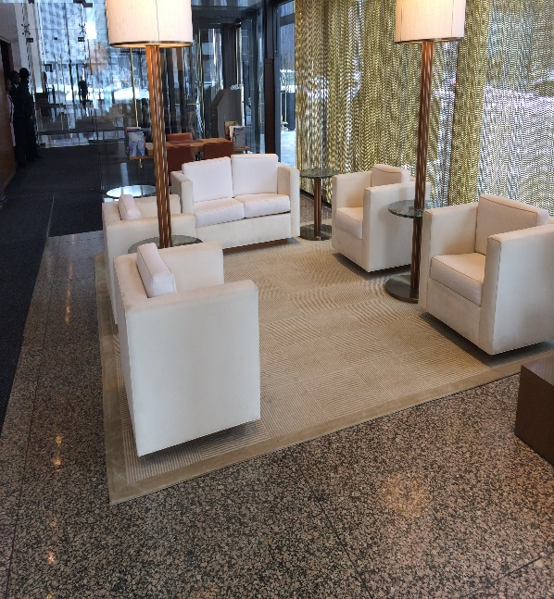

Pavilion upholstery-

- 2-Sofa (3 seat)……………………………….$100 ea.
- 24-Club Chairs………………………………$20 ea.
- 8- High Back Chairs…………………………$25 ea.
- 4- Luv Seat Sofas……………………………$75 ea.

Lobby upholstery-

- 2 Luv Seats
- 8 Sofa Chairs
- 2 Area Rugs

Upholstery in this area is to be done during 2 separate 3rd shift appointments

Price…………………………………………………………….$950.00

Club Lounge upholstery-

- Wool Sofa Chairs…………………………..$25 ea.

Miscellaneous Leather Chairs-

- Desk chairs stored in back hallway………..$25 ea.

PLEASE NOTE:

*48 hour cancellation notice required or a 15% cancellation fee will be charged.

*Property will move LOBBY furniture to an empty room prior to the arrival of the Renue System technicians.

*Renue Systems requires a $400 minimum service call. This is NOT in addition to any work scheduled.

*Hotel will provide complimentary parking during any service call. If none is available, cost for parking will be billed back to the hotel.

Note some staining in the upholstery fibers may be permanent and not removable with cleaning
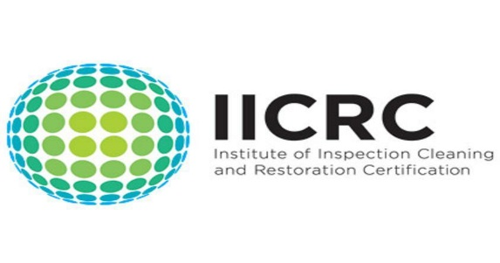

Please complete this service agreement, sign it and return it to your local Renue Systems service provider.

Scope of Service:

Description: ________________________________________________________________
______________________________________________________________________________

Payment Terms:

The sum of $_______ is the agreed upon price for the services rendered with payment to made as follows:

_____ payments each for $___________________ according to the following schedule:
______________________________________________________________________________

Please check here if your property will be paying by P-Card ___ or credit card ___

Card # _________________________ Card type _________________ Exp. date __________

3 Digit Security Code (back of card)____________________

Acceptance of Service Agreement

The above pricing, specifications, terms and conditions are satisfactory and you are hereby authorized to commence the work as specified.

Name: _______________________________________________ Property:__________________________________

Signature: ____________________________________________ P.O. # (if needed):___________________________

Title: ________________________________________________ Date: _____________________________________

Phone: _______________________________________________ Email: ____________________________________

