Erick Del Cid December 13, 2019
Director of Housekeeping

Level Hotel Chicago
1140 N. Wells St.
Chicago, IL 60610

Email: edelcid@stayinglevel.com

Dear Erick-

Thank you very much for the opportunity to earn your business. We are pleased to present you this proposal for the deep restoration cleaning of your carpets. If you have any questions regarding my proposal, please do not hesitate to call me.

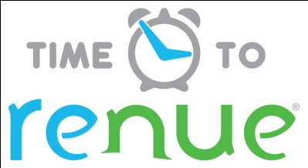

Why choose Renue Systems for your deep cleaning needs?

- We are the leading provider of comprehensive deep cleaning services exclusively to the hospitality industry – we have proudly serviced thousands of hotels over our 30 year history
- We are the only company that has been a North America approved vendor of Avendra since its formation
- Expertly trained, certified and uniformed employees that specialize in working in the hotel environment – no micromanaging of our team by your team is needed
- Proprietary equipment and chemicals, well-tested methodologies and significant ongoing R&D to provide top results
- Extremely responsive scheduling and highly flexible payment plans to meet your changing needs – we work when it is convenient to you and on a 24/7 basis
- Easy to understand and transparent pricing – and all our work is 100% guaranteed to your satisfaction

Biohazard material cleaning-

Cleaning and disinfecting of any contaminated areas from blood or other bodily fluids. All materials will be cleaned of gross material and then treated with an EPA registered multi-purpose quaternary disinfectant to kill any bloodborne pathogens. Hard surfaces can be cleaned and disinfected. Soft surfaces can be cleaned but only sanitized. Some porous items may not be safely sanitized and we may suggest disposal of those items.

Our crews work safely and in pairs. We will be in full hazmat suits/PPE required by OSHA for safe cleaning of biohazardous material. Please do NOT allow your guest or staff into the areas effected as it puts their health and safety at risk and may cross contaminate other areas of the facility as well as. We will be as discretionary as possible while working at your facility.

Cost for biohazard varies and is based on the cause and extent. All situations are different and in most cases we can’t give a firm price until the project is complete. Please remember that an estimate is just that, an estimate. Our years of experience has made us good at estimating the time needed but still should not be considered the final price.

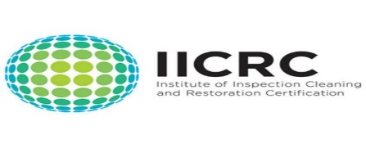
APPROVED VENDOR

Please complete this service agreement, sign it and return it to your local Renue Systems service provider.

Scope of Service:

Description: ________________________________________________________________

______________________________________________________________________________

Payment Terms:

The sum of $________________ is the agreed upon price for the services rendered with payment to made as follows:

____________ payments each for $___________ according to the following schedule:

______________________________________________________________________________

Please check here if your property will be paying by P-Card ___ or check ___

Card # _________________________ Card type _________________ Exp. date __________

3 Digit Security Code (back of card)____________________

We reserve the right to charge a credit card fee for a project paid by credit card exceeding $10,000

Acceptance of Service Agreement

The above pricing, specifications, terms and conditions are satisfactory and you are hereby authorized to commence the work as specified.

Name: _______________________________________________ Property:__________________________________

Signature: ____________________________________________ P.O. # (if needed):___________________________

Title: ________________________________________________ Date: _____________________________________

Phone: _______________________________________________ Email: ____________________________________

