Stacie West January 21, 2020
Operations Manager
Holiday Inn
500 Holiday Plaza Dr,
Matteson, IL 60443

Email: WestS@gfhotels.com

Dear Stacie:

Thank you very much for the opportunity to once again earn your business. We are pleased to present you this proposal for the high dusting of the overhangs inside of Bar Louie’s. If you have any questions regarding my proposal, please do not hesitate to call me.

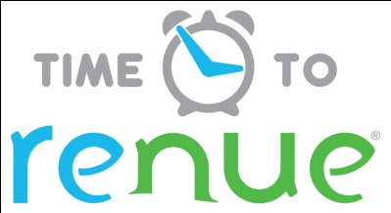

Why choose Renue Systems for your deep cleaning needs?

- We are the leading provider of comprehensive deep cleaning services exclusively to the hospitality industry – we have proudly serviced thousands of hotels over our 29 year history
- We are the only company that has been a North America approved vendor of Avendra since its formation
- Expertly trained, certified and uniformed employees that specialize in working in the hotel environment – no micromanaging of our team by your team is needed
- Proprietary equipment and chemicals, well-tested methodologies and significant ongoing R&D to provide top results
- Extremely responsive scheduling and highly flexible payment plans to meet your changing needs – we work when it is convenient to you and on a 24/7 basis
- Easy to understand and transparent pricing – and all our work is 100% guaranteed to your satisfaction

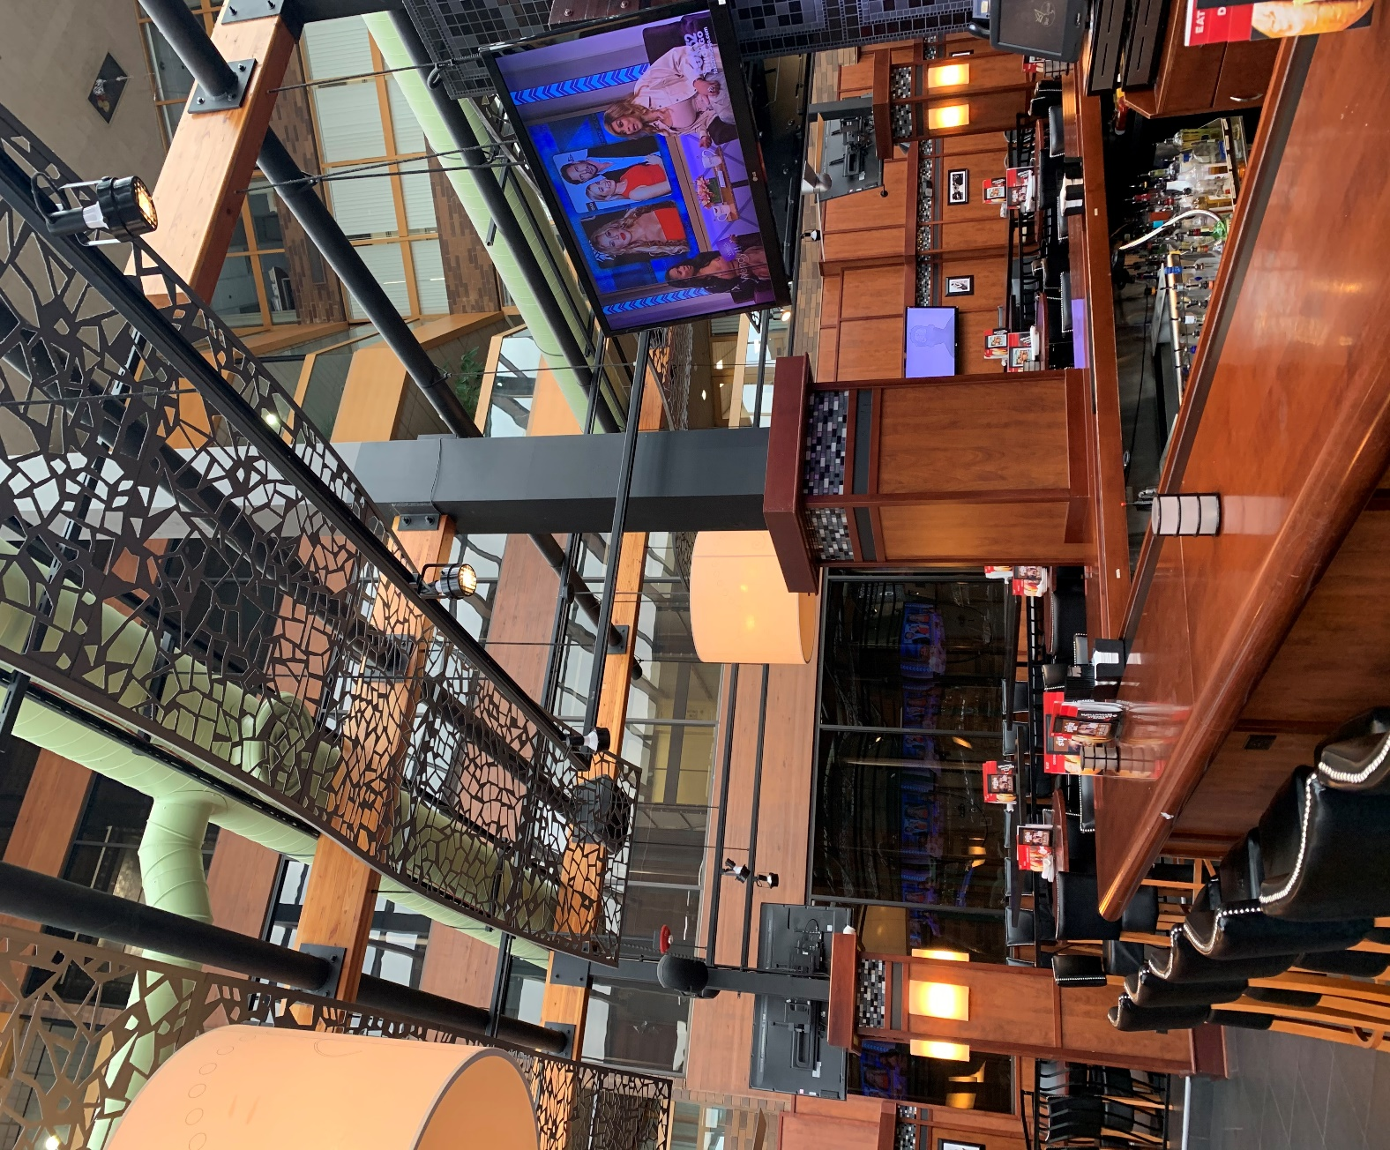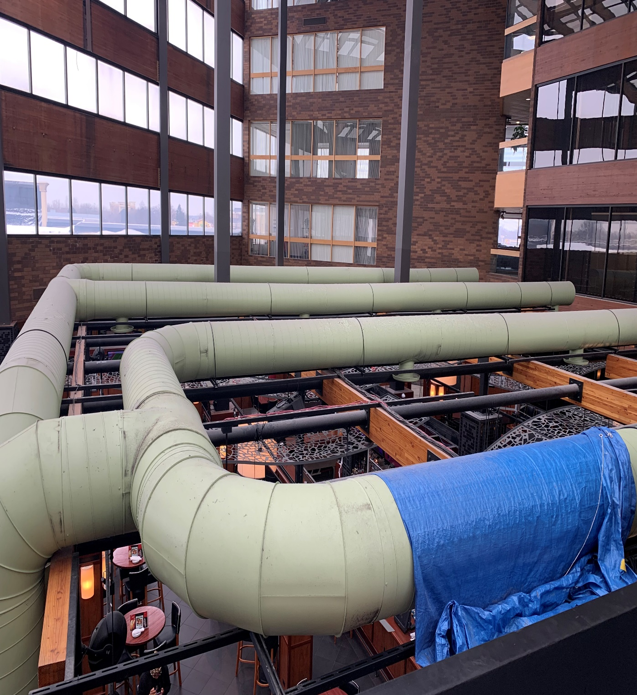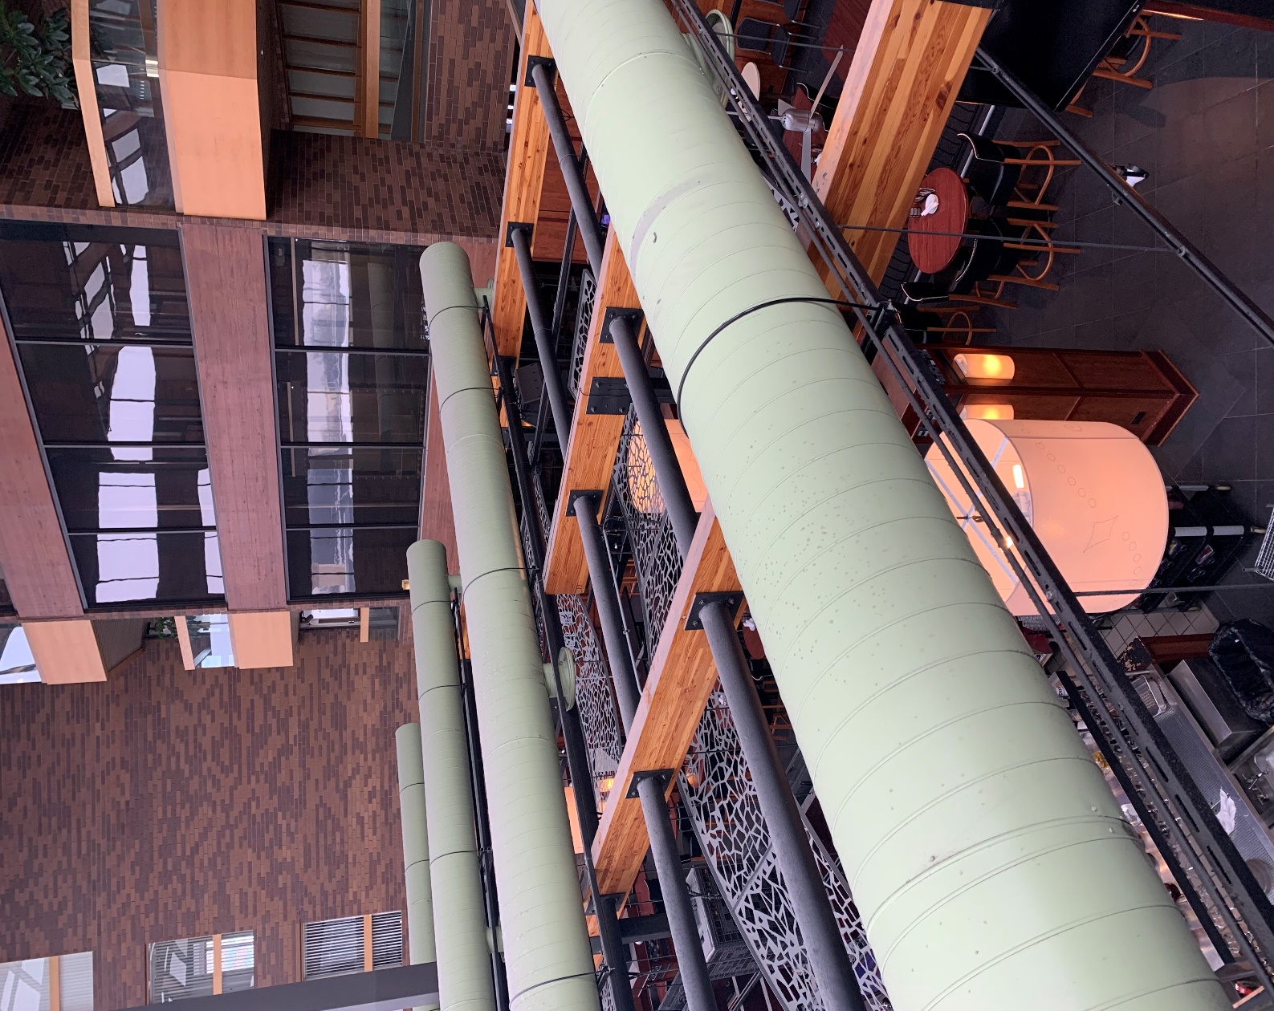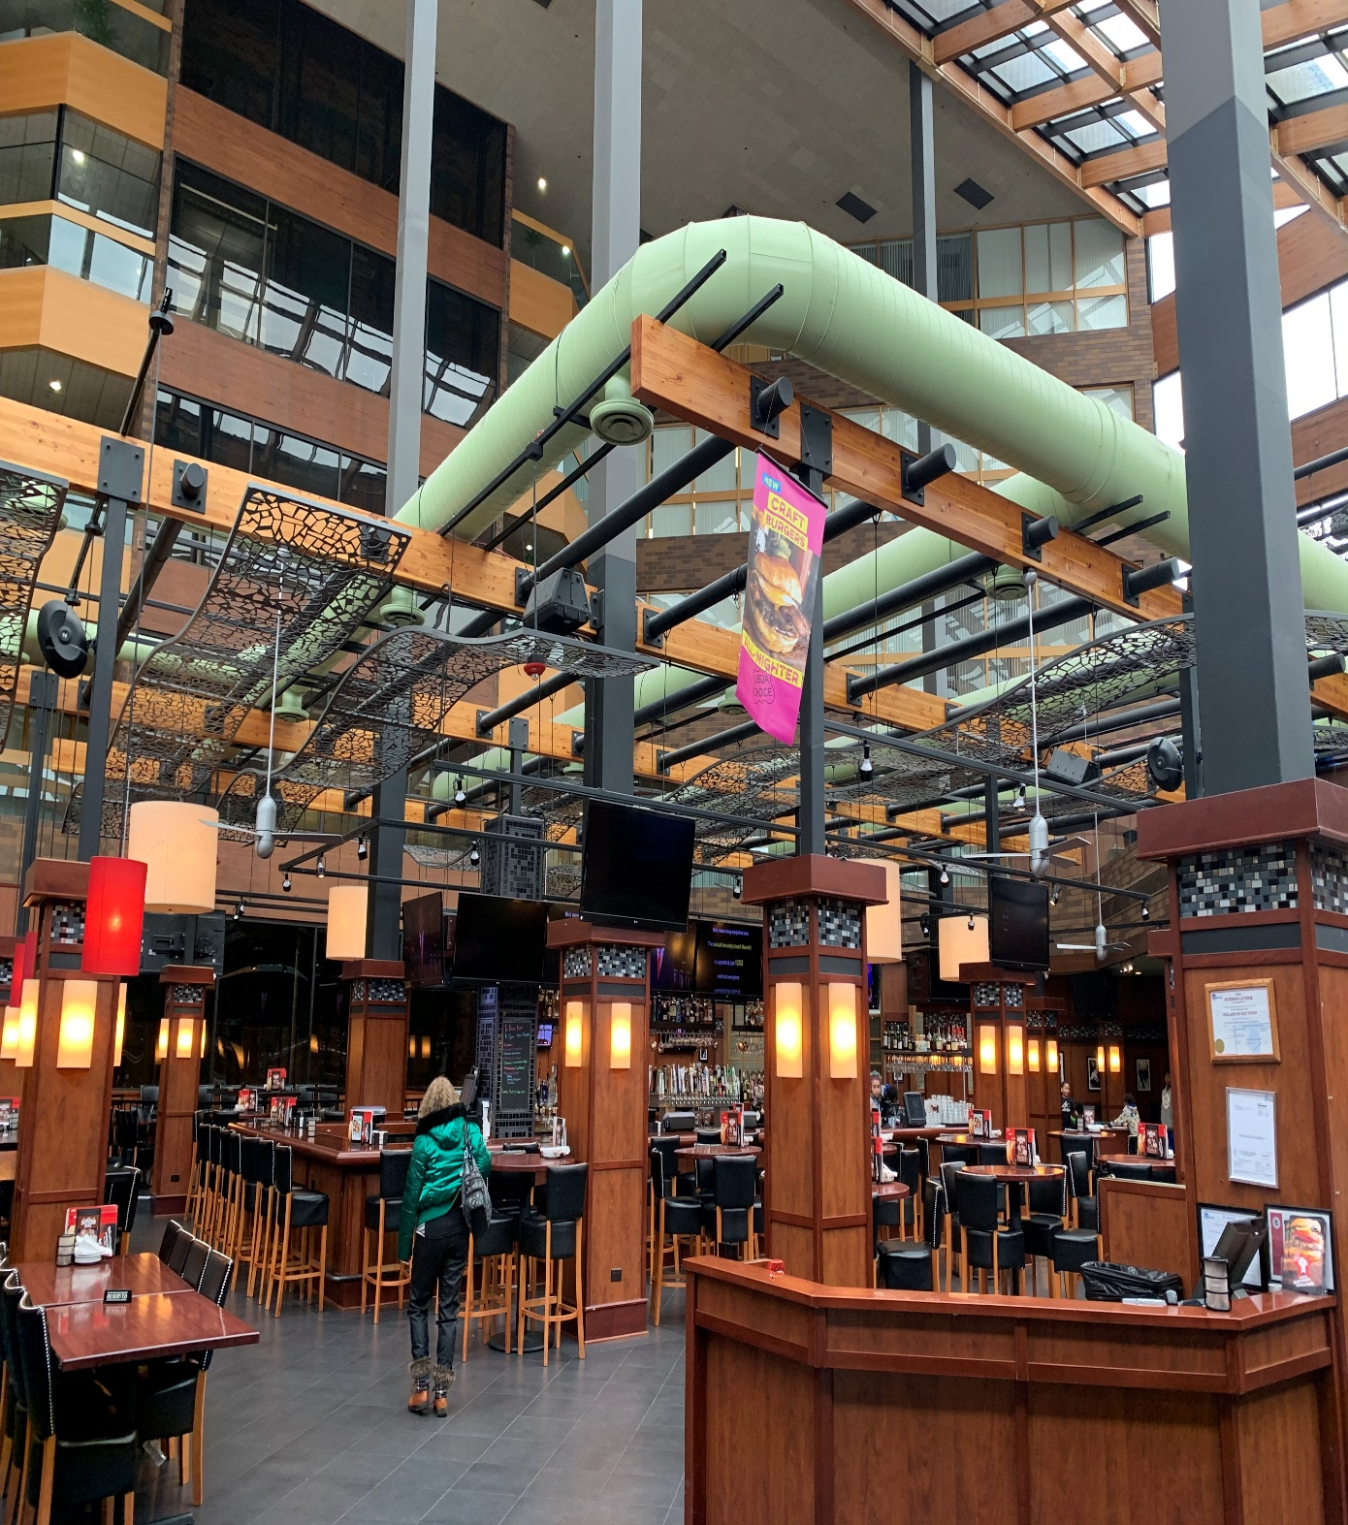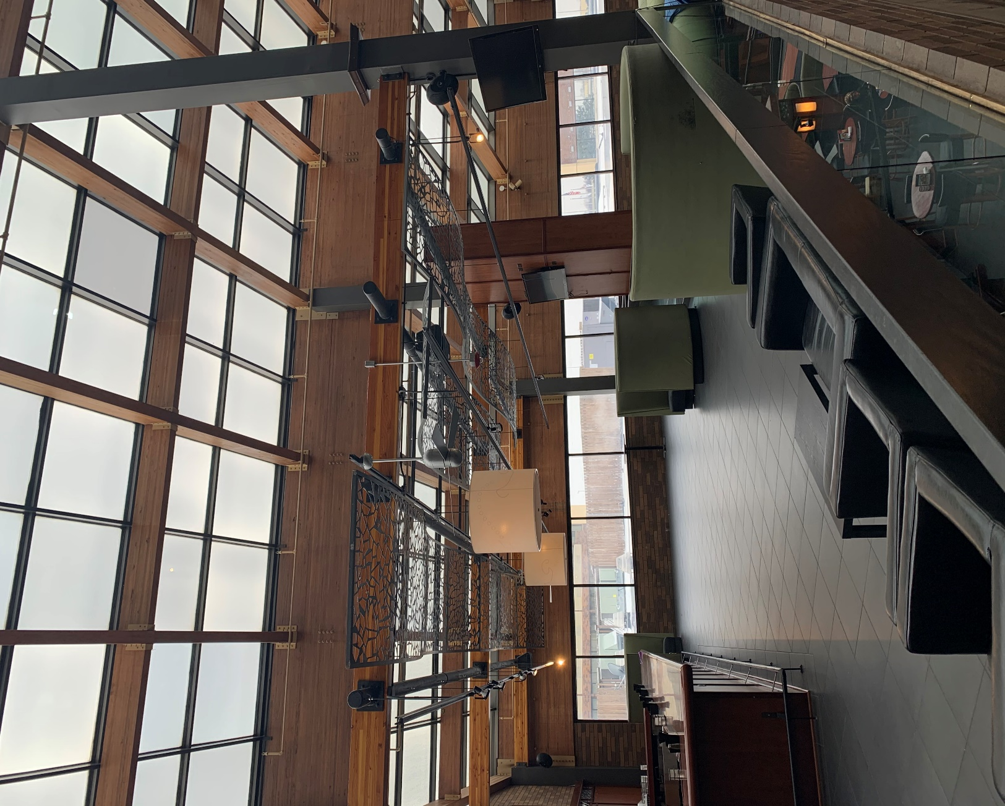

HIGH DUSTING OF AREAS IN BAR LOUIE’S

Project details and costs for proposed cleaning

High dusting using active HEPA vacuums and microfiber pads on telescoping poles of the following in Bar Louie’s: Main floor 16 foot high- Green ductwork, metal support beams, wooden beams, decorative metal framing, ceiling fans and wooden pillars. 2nd Floor 12 foot high- Metal support beams, wooden beams, decorative metal framing, ceiling fans and wooden pillars

We estimate the service taking 3 evenings to complete from start to finish working within time frame of restaurant hours. We will tarp bar to protect from falling dust.

Cost……………………….……………………………………………………$3,900.00

PLEASE NOTE:

*72 hour cancellation notice required or a 15% cancellation fee will be charged.

*Renue Systems requires a $550.00 minimum service call charge per visit. This is NOT in addition to any scheduled work.

*Hotel to provide complimentary parking during any scheduled work or cost for that will be billed back to the hotel.

We will be glad to afford you payment terms to work within your budget
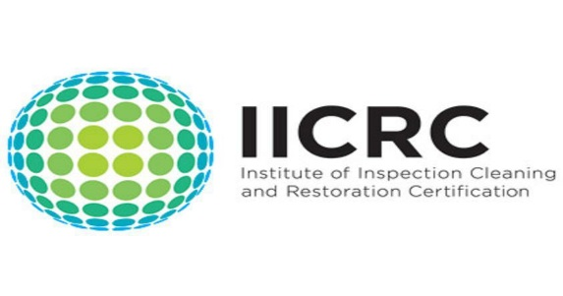

Please complete this service agreement, sign it and return it to your local Renue Systems service provider.

Scope of Service:

Description: ________________________________________________________________

______________________________________________________________________________

Payment Terms:

The sum of $________________ is the agreed upon price for the services rendered with payment to made as follows:

____________ payments each for $___________ according to the following schedule:

______________________________________________________________________________

Please check here if your property will be paying by P-Card ___ or check ___

Card # _________________________ Card type _________________ Exp. date __________

3 Digit Security Code (back of card)____________________

Acceptance of Service Agreement

The above pricing, specifications, terms and conditions are satisfactory and you are hereby authorized to commence the work as specified.

Name: _______________________________________________ Property:__________________________________

Signature: ____________________________________________ P.O. # (if needed):___________________________

Title: ________________________________________________ Date: _____________________________________

Phone: _______________________________________________ Email: ____________________________________

