Elise Derania April 24, 2019
Assistant General Manager
Hampton Inn Chicago O’Hare
3939 N Mannheim Road
Schiller Park, IL 60176

Email: ederania@hamptoninnohare.com

Dear Elise,

Thank you very much for interest in the services we provide to the hospitality industry. We are pleased to present you this proposal for the deep cleaning of your PTAC units. If you have any questions regarding my proposal, please do not hesitate to call me.

Why choose Renue Systems for your deep cleaning needs?

- We are the leading provider of comprehensive deep cleaning services exclusively to the hospitality industry – we have proudly serviced thousands of hotels over our 30 year history
- We are the only company that has been a North America approved vendor of Avendra since its formation
- Expertly trained, certified and uniformed employees that specialize in working in the hotel environment – no micromanaging of our team by your team is needed
- Proprietary equipment and chemicals, well-tested methodologies and significant ongoing R&D to provide top results
- Extremely responsive scheduling and highly flexible payment plans to meet your changing needs – we work when it is convenient to you and on a 24/7 basis
- Easy to understand and transparent pricing – and all our work is 100% guaranteed to your satisfaction

Project details and cost for cleaning of PTAC units

Step #1: Shut off power to unit
Step #2: Remove power quick coupler from PTAC unit (located under unit on right side usually held on by two screws and a black access cap). If hardwired, hotel must disconnect prior to our service.
Step #3: Remove dirty air filter and vacuum
Step #4: Remove plastic front cover to gain access to front coil and components of unit
Step #5: Unscrew four screws on each side of unit holding the PTAC to the wall sleeve. Cover electric control panel with plastic
Step #6: Remove air discharge cover and spray inner side of interior coil and blower wheel with Simple Green cleaning solution.
Step #7: Pressure spray coils and blower wheel with low psi (about 50-75psi) water and extract
Step #8: Inspect upper drain pan and hose (if plugged or restricted, remove and flush to ensure proper drainage)
Step #9: Spray outer coils with Simple Green cleaning solution
Step #10: Pressure spray outer coils with low psi water
Step #11: Pressure spray and extract debris from lower pan that can restrict proper drainage
Step #12: Inspect lower drainage trap (if plugged or restricted, remove and flush to assure proper drainage)
Step #13: Slide unit back into wall sleeve and replace for bracing screws
Step #14: Replace plastic cover
Step #15: Install new air filter or cleaned filter
Step #16: Connect power quick coupler and replace black cap and screws. If hardwired, hotel engineer is to reconnect
Step #17: Test unit to ensure it is working

Cleaning only of 156 PTAC units…….…………….…….………………. $5,304.00

Optional installation of biocide tablets/strips………………………………….. $2.00 ea.

*We cannot clean blower wheels on Trane PTAC units. Water channels to the control board and unit could short circuit.

We cannot clean PTAC units that are hardwired to electric, they must be on plugs or quick disconnects. If you have hardwired units, your engineers must disconnect prior to our cleaning and they must reconnect units after we done cleaning them.

* In order for us to keep our costs down, we would like access to occupied rooms during the cleaning in order to complete the work in the time allotted for your project. We can do the entire property in just a few days minimizing the impact to guests and staff. Please notify guests of the pending service. We will not do rooms that have DND signs or are physically occupied with a guest. Guests can also choose which of the days we do the service in their rooms but we prefer to work in the most contiguous fashion possible without too much jumping around. Most properties just assign a staff member to open doors for us and to provide a presence during our cleaning. We are in and out of the room quickly in 20 minutes or so. New policy effective August 2021 please read: Due to the labor shortage and high demand on our services, we must complete your project on the dates scheduled. If you have remaining rooms that you could not allow us access to during the dates agreed upon, you will be invoiced in full and there will be an additional charge to reschedule those remaining rooms. Thank you for your understanding during these challenging times.

*48 hour cancellation notice required or a 15% cancellation fee will be charged.

*Hotel will provide complimentary parking during any scheduled service.

*Hotel will provide access to guestrooms in the best contiguous fashion as possible.

*All invoicing will be 30 days net terms.

We will be glad to afford you payment terms to work within your budget

Inside of each unit, we will place a sticker of completion filled out with corrisponding information

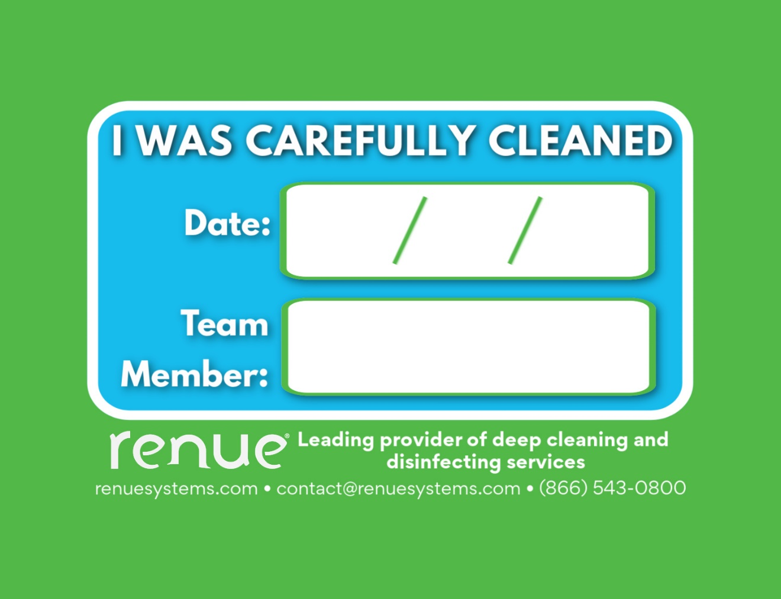

A Hilton Supply Management Vendor

Please complete this service agreement, sign it and return it to your local Renue Systems service provider.

Scope of Service:

Description: ________________________________________________________________

______________________________________________________________________________

Payment Terms:

The sum of $________________ is the agreed upon price for the services rendered with payment to made as follows:

____________ payments each for $___________ according to the following schedule:

______________________________________________________________________________

Please check here if your property will be paying by P-Card ___ or check ___

Card # _________________________ Card type _________________ Exp. date __________

3 Digit Security Code (back of card)____________________

We reserve the right to charge a credit card fee for a project paid by credit card exceeding $10,000

Acceptance of Service Agreement

The above pricing, specifications, terms and conditions are satisfactory and you are hereby authorized to commence the work as specified.

Name: _______________________________________________ Property:__________________________________

Signature: ____________________________________________ P.O. # (if needed):___________________________

Title: ________________________________________________ Date: _____________________________________

Phone: _______________________________________________ Email: ____________________________________

