Stephanie Portrey November 7, 2017
Assistant General Manager
Ct. Yard Lincolnshire
505 Milwaukee Ave
Lincolnshire, IL 60069

Email: Stephanie.portrey@marriott.com

Dear Ms. Portrey,

Thank you very much for the opportunity to once again earn your business. We are pleased to present you this proposal for the deep restoration cleaning of your tile and grout. If you have any questions regarding my proposal, please do not hesitate to call me.

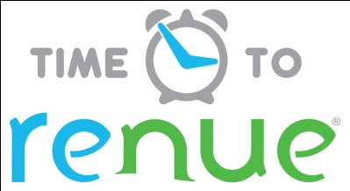

Why choose Renue Systems for your deep cleaning needs?

- We are the leading provider of comprehensive deep cleaning services exclusively to the hospitality industry – we have proudly serviced thousands of hotels over our 30 year history
- We are the only company that has been a North America approved vendor of Avendra since its formation
- Expertly trained, certified and uniformed employees that specialize in working in the hotel environment – no micromanaging of our team by your team is needed
- Proprietary equipment and chemicals, well-tested methodologies and significant ongoing R&D to provide top results
- Extremely responsive scheduling and highly flexible payment plans to meet your changing needs – we work when it is convenient to you and on a 24/7 basis
- Easy to understand and transparent pricing – and all our work is 100% guaranteed to your satisfaction

At your property we will perform the following methodology, a well-tested technique we have developed over the years in conjunction with the leading deep floorcare cleaning association and the largest floorcare manufacturers:

Our deep clean process-

Step #1: Pre-Spray tile and grout with alkaline detergent to loosen soiling and enhance appearance of the grout lines. All of our Hotel Hygiene® Plus chemicals are formulated specifically for Renue Systems.

Step #2: Power Wash tile and grout using state-of-the-art rotary scrubbers delivering 1200psi of hot water with cutting-edge starter detergents to accelerate soil release.

Step #3: Clean and neutralize all tile & grout with a pH balance solution and clean water rinse. This process removes all residues from cleaning agents and leaves the tile floor free from chemical build up that would otherwise leave a haze discoloring your floors appearance.

Step #4 (optional): Seal all grout with an acrylic mortar sealer to each grout line. Speed dry first application and then repeat the process for superior protection.

Project details and costs for proposed cleaning

Service pack #1 Tile & Grout Deep Cleaning:

- All lobby areas including entrance, front desk areas and
support hallways………………………………………………$452.55
  - Seal all the grout above……………………………….$149.00
- Men’s & Ladies washrooms…………………………………..$250.00
  - Seal all the grout above………………………………..$82.50
- Bistro restaurant area………………………………………….$206.50
  - Seal all the grout above………………………………..$68.15

PLEASE NOTE

Renue Systems will not be responsible for the following (but we can address):

- Compromised or missing grout
- Chipped or cracked tiles
- Flooring where grout lines have been painted and are not the original grout color
- Uneven surface coloring and cracks may be evident after floor is cleaned and free of sealer/wax and other coatings
- Some staining may be permanent in the stone and grout

*Some staining in the grout may be permanent and not removable with cleaning.

*Sealing the grout doesn’t mean it will stay clean forever. It simply helps limit permanent staining and aids in cleaning.

*48 hour cancellation notice required or a 15% cancellation fee will be charged.

*Hotel will provide complimentary parking during any scheduled work or cost will be billed back to the hotel.

We will be glad to afford you payment terms to work within your budget

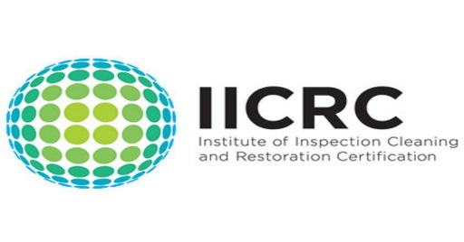
APPROVED VENDOR

Please complete this service agreement, sign it and return it to your local Renue Systems service provider.

Scope of Service:

Description: ________________________________________________________________

______________________________________________________________________________

Payment Terms:

The sum of $________________ is the agreed upon price for the services rendered with payment to made as follows:

____________ payments each for $___________ according to the following schedule:

______________________________________________________________________________

Please check here if your property will be paying by P-Card ___ or check ___

Card # _________________________ Card type _________________ Exp. date __________

3 Digit Security Code (back of card)____________________

Acceptance of Service Agreement

The above pricing, specifications, terms and conditions are satisfactory and you are hereby authorized to commence the work as specified.

Name: _______________________________________________ Property:__________________________________

Signature: ____________________________________________ P.O. # (if needed):___________________________

Title: ________________________________________________ Date: _____________________________________

Phone: _______________________________________________ Email: ____________________________________

